lab 7:

name : Muhammad usama

roll no: 17f-8195.

Section B.

Task 1:

#include<iostream>

#include<string>

using namespace std;

class student

{

private:

string fname;

string lname;

static int count;

public:

student(const string fn,const string ln)

{

fname=fn;

lname=ln;

count++;

}

student(const student &st)

{

fname=st.fname;

lname=st.lname;

count=st.count;

}

student():fname(0),lname(0)

{

count=0;

}

string getfname() const

{

//return this->fname;

}

string getlname() const

{

//return this->lname;

}

int getcount() const

{

//return this->count;

}

~student()

{

cout<<"dynamic memory free now that we take"<<endl;

}

};

int student::count=0;

int main()

{

student ob1,ob2,ob3;

ob2=ob3;

system("pause");

return 0;

}

Task 2:

#include<iostream>

using namespace std;

class inventory

{

private:

int itemno;

int quantity;

double costs;

static double tcost;

public:

inventory()

{

itemno=0;

quantity=0;

costs=0;

tcost=0;

}

inventory(int itno,int quan,double cs)

{

itemno=itno;

quantity=quan;

costs=cs;

}

void setitemno(int ino)

{

itemno=ino;

}

void setquantity(int q)

{

quantity=q;

}

void setcosts(int cs)

{

costs=cs;

}

int getitemno() const

{

return itemno;

}

int getquantity() const

{

return quantity;

}

double getcosts() const

{

return costs;

}

double getttcost() const

{

return tcost;

}

~inventory()

{

cout<<"free all dynamic memory"<<endl;

}

};

double inventory::tcost=0;

int main()

{

int itno=0;

int quantity=0;

double costs=0;

double tcost=0;

cout<<"all entaries must be grater than zero"<<endl;

do

{

cout<<"eneter itemnumber : ";

cin>>itno;

}

while(itno<0);

do

{

cout<<"eneter quantity : ";

cin>>quantity;

}

while(quantity<0);

do

{

cout<<"eneter cost of : ";

cin>>quantity;

}

while(costs<0);

inventory ob1(itno,quantity,costs);

cout<<"all entaries must be grater than zero"<<endl;

cout<<"enetr data for 2nd obj"<<endl;

do

{

cout<<"eneter itemnumber : ";

cin>>itno;

}

while(itno<0);

do

{

cout<<"eneter quantity : ";

cin>>quantity;

}

while(quantity<0);

do

{

cout<<"eneter cost of : ";

cin>>costs;

}

while(costs<0);

inventory obj2(itno,quantity,costs);

inventory obj3=obj2;

cout<<"item number : "<<obj3.getitemno()<<endl;

cout<<"costs of item : "<<obj3.getcosts()<<endl;

cout<<"quantity of item : "<<obj3.getquantity()<<endl;

system("pause");

return 0;

}

Result:

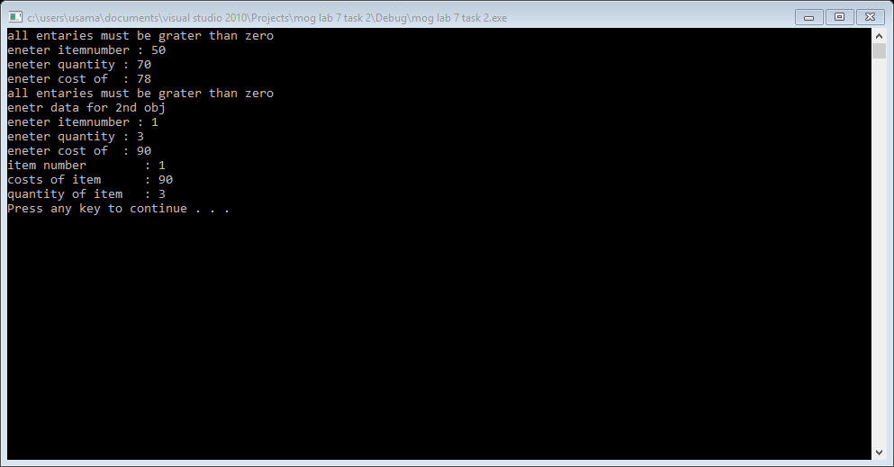

Task 3:

#include<iostream>

#include<string>

using namespace std;

class person

{

private:

string name;

int age;

bool employment;

string fsports;

public:

person():name("usama"),age(0),employment(1),fsports("swmming")

{ }

string getname()

{

return name;

}

int getage()

{

return age;

}

bool getemployment()

{

return employment;

}

string getfsports()

{

return fsports;

}

};

int main()

{

person p1,p2;

p2=p1;

cout<<"name of person : "<<p2.getname()<<endl;

cout<<"age of person : "<<p2.getage()<<endl;

cout<<"employee status : "<<p2.getemployment()<<endl;

cout<<"favaroit sports of prson :"<<p2.getfsports()<<endl;

system("pause");

return 0;

}

Result:

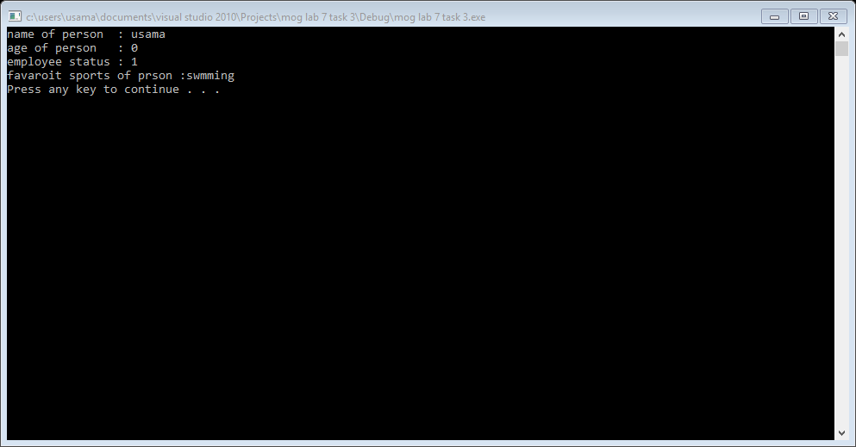

Task 4:

#include<iostream>

#include<time.h>

using namespace std;

class player1

{

public:

static int run;

static int count;

};

int player1::run=0;

int player1::count=0;

class player2

{

public:

static int run;

static int count;

};

int player2::run=0;

int player2::count=0;

int main()

{

int r=0;

srand(time(0));

r=rand()%3+1;

player1::run=5;

player1::count=r;

r=rand()%3+1;

player1::run=5;

player1::count=r;

if(player1::run>=player2::run&&player1::count>player2::count)

{

cout<<"player1 win "<<endl;

cout<<"player1 runs : "<<player1::run<<endl;

cout<<"player counts: "<<player1::count<<endl;

}

else

{

cout<<"player2 win "<<endl;

cout<<"player2 runs : "<<player2::run<<endl;

cout<<"player2 counts: "<<player2::count<<endl;

}

system("pause");

return 0;

}

Result:

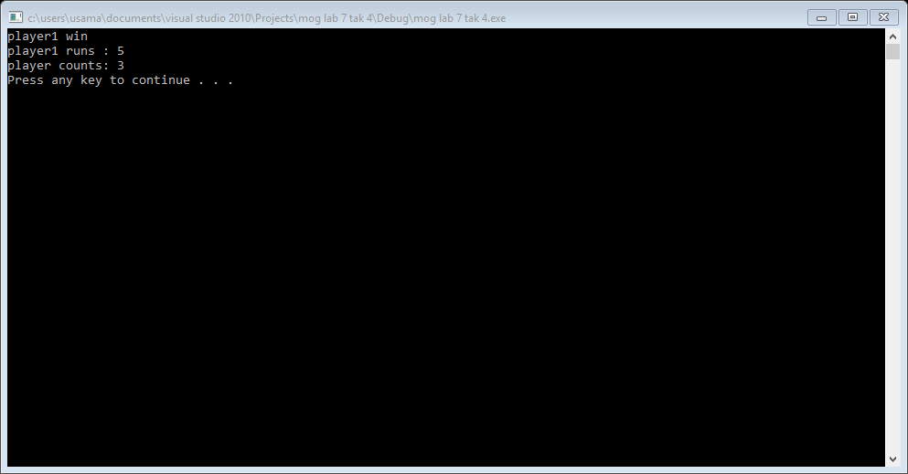

Task 5:

#include<iostream>

#include<string>

using namespace std;

class employee

{

private:

const int id;

const string name;

int total_hour;

int salary;

static const int organization_code;

string home_add;

static string organization_add;

static int max_hour;

static const int organization_city_code;

};

int main()

{

int id;

employee obj1;

system("pause");

return 0;

}